Limiting Modifier

🔹 What Is Limiting Modifier?
# Source: AI Source: Provided by: [Data Path: Persons Table -> ID Column: 1, Name_En Column: Motasem Essam] -> From: [Chatgpt (GPT‑5 Mini)] on [8/7/2025]
A limiting modifier is a word or phrase that restricts, specifies, or limits the meaning of another word (usually a noun, verb, or clause) by narrowing the scope of reference or quantity.

🔸 Function:
# Source: AI Source: Provided by: [Data Path: Persons Table -> ID Column: 1, Name_En Column: Motasem Essam] -> From: [Chatgpt (GPT‑5 Mini)] on [8/7/2025]
It answers questions like:
"How many?", "Which ones?", "To what extent?", "Only who/what?"

🔸 Common Types of Limiting Modifiers:
# Source: AI Source: Provided by: [Data Path: Persons Table -> ID Column: 1, Name_En Column: Motasem Essam] -> From: [Chatgpt (GPT‑5 Mini)] on [8/7/2025]
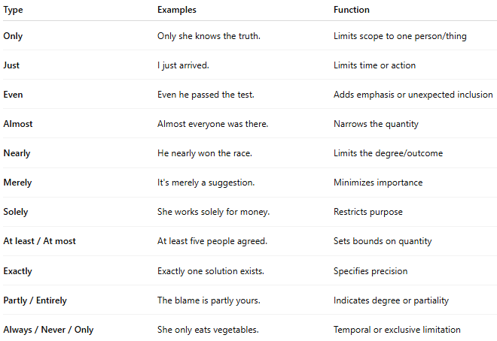
Type | Examples | Function
Only | Only she knows the truth. | Limits scope to one person/thing
Just | I just arrived. | Limits time or action
Even | Even he passed the test. | Adds emphasis or unexpected inclusion
Almost | Almost everyone was there. | Narrows the quantity
Nearly | He nearly won the race. | Limits the degree/outcome
Merely | It's merely a suggestion. | Minimizes importance
Solely | She works solely for money. | Restricts purpose
At least / At most | At least five people agreed. | Sets bounds on quantity
Exactly | Exactly one solution exists. | Specifies precision
Partly / Entirely | The blame is partly yours. | Indicates degree or partiality
Always / Never / Only | She only eats vegetables. | Temporal or exclusive limitation

🔸 Examples in Sentences:
# Source: AI Source: Provided by: [Data Path: Persons Table -> ID Column: 1, Name_En Column: Motasem Essam] -> From: [Chatgpt (GPT‑5 Mini)] on [8/7/2025]
- Only John knows the answer.
- I just need a minute.
- She almost cried.
- He spoke merely out of obligation.
- There were exactly ten guests.
- We are partly responsible.

🔸 Placement Tips:
# Source: AI Source: Provided by: [Data Path: Persons Table -> ID Column: 1, Name_En Column: Motasem Essam] -> From: [Chatgpt (GPT‑5 Mini)] on [8/7/2025]
- Be cautious: incorrect placement can change meaning.
  - ✔ Only John saw the man. → No one but John saw him.
  - ✔ John only saw the man. → He didn’t hear or touch him.
  - ✔ John saw only the man. → He saw no one else.

